Evaluation Strategy

Success Metrics
The classification system offered on the basis of brain tumour will be tested by the most topically accepted measures of multi-class medical image classification, which will guarantee the provision of robustness and parallels between the proposed study and previous research (Tandel et al., 2021). Overall correctness is estimated using accuracy, and more detailed information is needed on the performance in each of the classes, which is why accuracy, recall, and F1-score are useful measures (Sultana et al., 2020).
Accuracy = (TP + TN) / (TP + TN + FP + FN)
Precision = TP / (TP + FP)
Recall = TP / (TP + FN)
F1-score = 2* (Precision × Recall)/(Precision + Recall).
Macro-averaged and weighted-average F1-scores will be presented to evaluate the balanced performance in terms of tumour classes and the possibility of bias against the classes (Ghassemi et al., 2021).

Critical Assessment of the Technical Performance and Social Impact
Quantitative measures based on the independent test data set will be quantitative metrics such as accuracy, precision, recall, and F1-score, which are conventional measures of reliability (Tandel et al., 2021) in medical image classification tasks (Pereira et al., 2020). Confusion matrices will be interpreted both to determine the patterns of misclassification and to determine the trade-off between false positives and false negatives (Arun et al., 2021) in particular, when dealing with tumour classes that share similar visual characteristics. Besides numerical assessment, Grad-CAM visualisations will be utilised to qualitatively determine whether the predictions made by the model are influenced by clinically relevant areas in the MRI images, which justifies interpretability and transparency (Selvaraju et al., 2020).
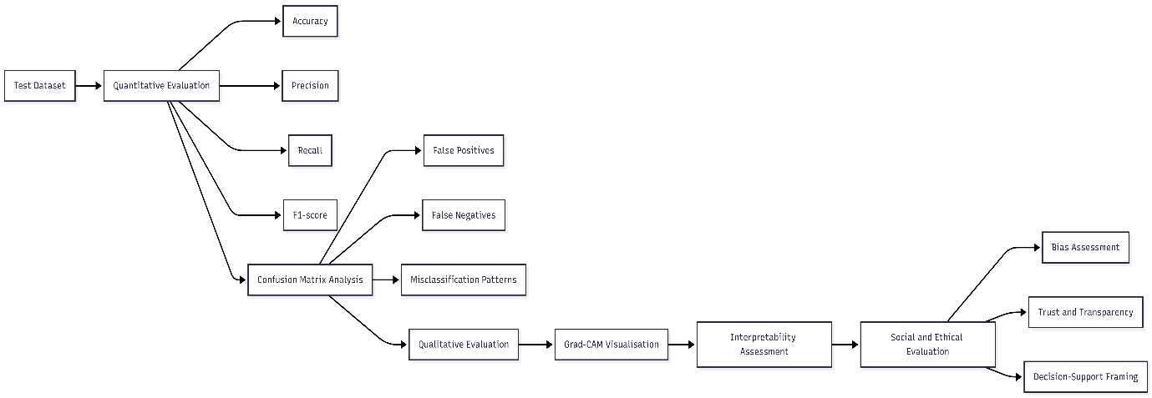
Figure 5 : Flowchart illustrating the technical evaluation and social impact assessment of the proposed explainable deep learning system.
Socially and ethically, the analysis will be critical on the risks of using deep learning systems in healthcare, which include algorithmic bias, over-trusting automated predictions, and diminished clinical accountability (Holzinger et al., 2020). To reduce these risks, the system is clearly presented as (Tjoa and Guan, 2020) a decision-support system, but not a diagnostics power. Explainable AI approaches are being considered with regard to their technical understanding as well as their contribution to building trust, responsibility, and responsible use of AI in clinical settings (Samek et al., 2021).

Project Management & GitHub Integration
Each phase of the project will be properly documented and version-managed with the help of GitHub in accordance with the GitHub Evidence Rule that requires such transparency, accountability, and constant involvement of the project. Prioritisation will be given on incremental development and frequent and descriptive commits will be employed to document the progress so as to avoid huge code dumped at the end of the development process.
This will aid in traceability of personal contributions and is in keeping with the practise of professional software engineering. The GitHub Project Board will be used to monitor the progress of tasks on a weekly basis where the task will be created as an issue, and organised into a set of stages, including To Do, In progress, and Completed. The issues will be clearly set, time-limited, and allocated to a particular person to facilitate the equal distribution of the workload and responsibility. The progress will be checked every week, which will allow recognising the technical issues early and addressing them in time. All the project activities will be also recorded and evaluated by storing non-code contributions such as research notes and design decisions in issues, as well as by uploading them to a repository.

Roles and Responsibilities
S.no | Team Member Name | Role | Responsibilities
1 | Balu Krishna Gade | Project Lead &Github Co-Ordinator | Plans tasks. Manages timeline. Oversees integration.
2 | Molla. Ganja Shaida | Data Engineer | Prepares dataset. Cleans images. Manages data splits
3 | Vijayagayathri Guntupalli | Model Developer & Evaluation Lead | Builds CNN model. Trains network. Tunes parameters. Computes metrics
4 | Venkata Naga Suresh Kumar | XAI & Presentation Lead | Implements Grad-CAM. Analyses results and presentation preparation.
5 | Mounika Chinta | Documentation Lead | Writes report. Maintains README.md. Handles ethics section.
Table 1 : Roles & Responsibilites for each member

Dataset Description and Feasibility
The Brain Tumour MRI Dataset is a publicly accessible image dataset hosted on Kaggle that can be used to conduct research on the topic of automated brain tumour classification with the use of deep learning (Masoud Nickparvar et al., 2024). It has more than 7,000 MRI images of human brains in four different classes: glioma, meningioma, pituitary tumour, and no tumour, which guarantees the representation of both pathological and normal cases. This multi-class model facilitates the creation and assessment of convolutional neural network models and the associated computer vision algorithms
The photographs differ in anatomy and neoplasm image, which represent the actual clinical variability and make it hard to generalise models. Images have already been labelled, which allows supervised learning and evaluation metrics, like accuracy, precision, recall, and F1-score. The balanced distribution of the dataset in categories decreases the bias of the classes and enhances the reliability in performance measurement (Disci et al., 2025). Since it is publicly available and is commonly utilised in the studies, this dataset can ensure the possibility of reproducibility and meaningful comparisons of the studies in medical AI imaging.

Gantt Chart
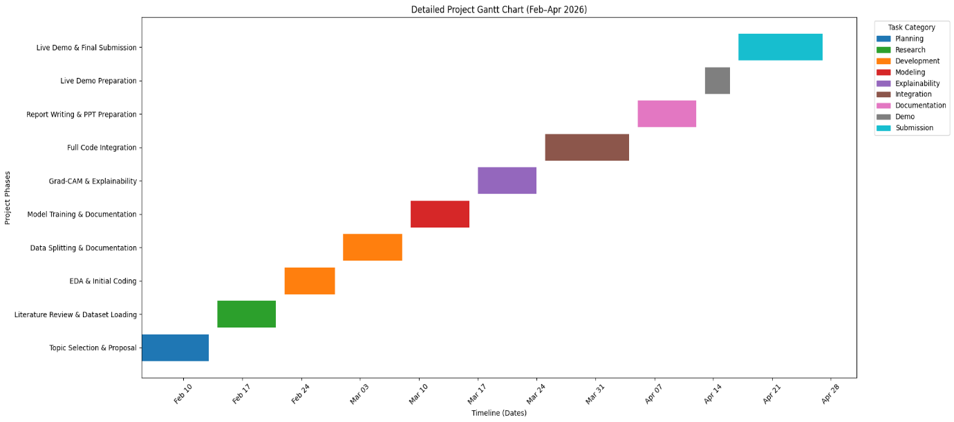
Figure 6: Detailed Project Gantt Chart (Feb-Apr 2026)

